**Sustainability Meets Strategy: Portfolio Optimization with ESG Insights**

***Harshitha Suresh***

***Introduction***

Environmental, Social, and Governance (ESG) scores have become critical for evaluating corporate responsibility and ethical practices. This analysis leverages ESG scores to optimize portfolio performance while balancing financial returns with sustainable practices. Combining data-driven insights and advanced economic modeling, this study provides actionable recommendations for creating efficient ESG-focused investment strategies.

***Data Sources***

The data for this analysis was sourced from two primary repositories. Yahoo Finance provided detailed financial information, including stock prices, sectors, and ESG scores, while DataHub supplied a comprehensive list of securities constituting the S&P 500 index. These resources formed the backbone of the dataset, ensuring thorough coverage of financial and sustainability metrics.

<https://datahub.io/core/s-and-p-500-companies#resource-constituents>

***Data Formation Process***

***Integration and Cleaning***

The initial stage involved consolidating datasets from multiple sources, including risk_data, esg_data, security_data, and snp. Using an inner join approach, only securities common across all datasets were retained, ensuring consistency and alignment in subsequent analyses. To maintain data integrity, rows with missing values in key metrics, such as totalEsg, were removed. This cleaning step ensured that the analysis was conducted on a complete and reliable dataset.

***Categorization and Grouping***

The dataset was further enhanced by categorizing companies into meaningful groups. Market capitalization was segmented into small, medium, and large categories based on percentile distributions. Similarly, peer groups were streamlined by consolidating less frequent groups under the label "Others," while retaining the most prominent ones. ESG scores were classified into five distinct risk levels—Severe Risk, High Risk, Medium Risk, Low Risk, and No Risk—using quantile-based thresholds, enabling a granular understanding of ESG performance across the dataset.

***Final Dataset Overview***

The resulting dataset contained 465 rows and 25 columns, encapsulating key metrics such as social, environmental, governance, and total ESG scores. Additional fields included market capitalization categories and peer group classifications, providing a robust foundation for portfolio construction and analysis.

***Portfolio Analysis***

***Methodology***

The analysis involved constructing portfolios based on different ESG score dimensions, each comprising 20 securities to maintain uniformity. An equally weighted portfolio spanning all industries served as the benchmark. Four ESG-driven portfolios were analyzed, focusing respectively on social, governance, environmental, and total ESG scores. The methodology ensured comparability across portfolios and highlighted the influence of ESG criteria on financial performance.

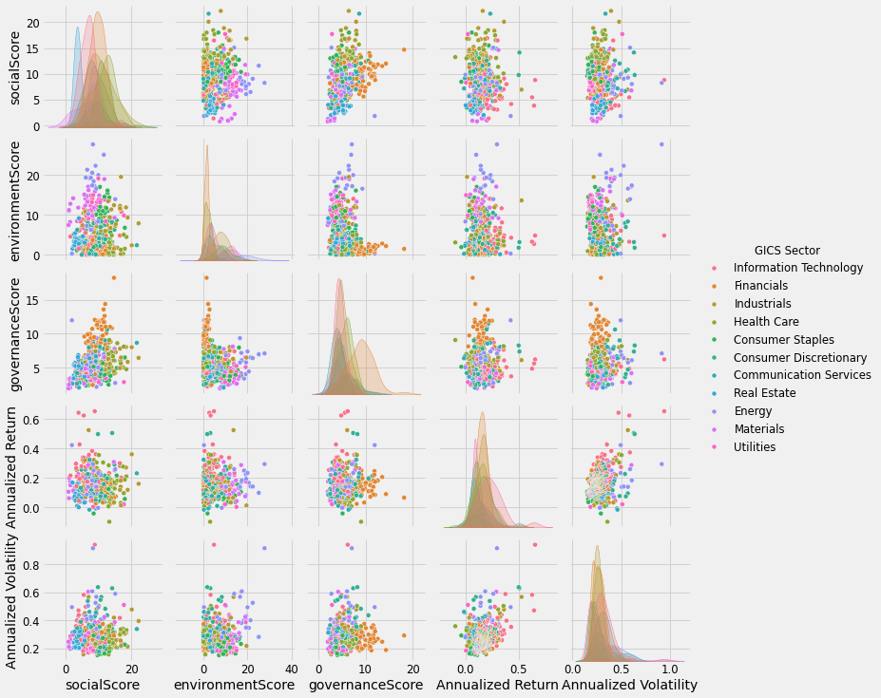

***Stock Selection Strategies***

***1. Broad Market Selection***

This approach evaluated performance across all industries without sector-specific focus. Securities were selected based on their rankings in the top 30 for each ESG category. The cumulative performance revealed that the socialScore portfolio slightly outperformed the benchmark over time, maintaining a Sharpe ratio of 0.8519. While the environmentScore portfolio exhibited higher volatility, the socialScore portfolio offered the best risk-adjusted returns.

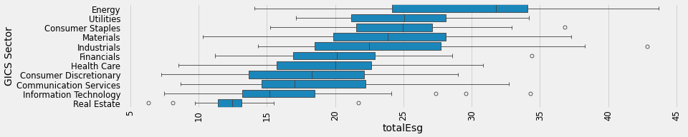

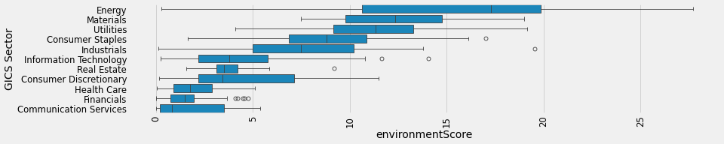

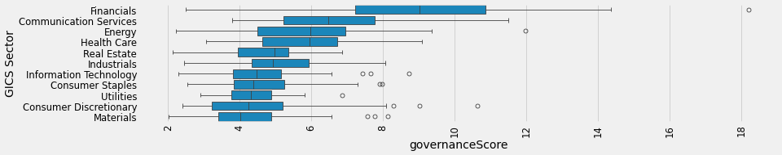

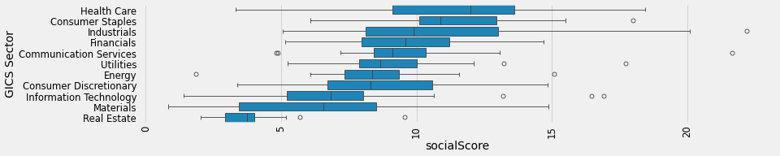

***2. Outperforming Sectors***

Focusing on high-performing sectors such as Information Technology, Consumer Discretionary, and Industrials, this strategy targeted top ESG-ranked securities. The governanceScore portfolio emerged as the leader, achieving the highest annualized return (21.41%) and Sharpe ratio (0.902). Governance-focused strategies excelled in high-growth sectors, demonstrating their potential for enhanced financial performance.

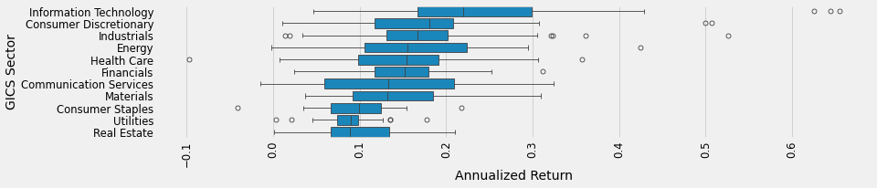

***3. Excluding Underperforming Sectors***

By excluding sectors with weak historical performance—Utilities, Real Estate, and Consumer Staples—this strategy refined portfolio composition. The socialScore portfolio delivered superior returns of 17.50% and competitive risk-adjusted performance. Excluding underperforming sectors also reduced volatility, enhancing portfolio stability.



***4. Sector-Focused Selection***

This approach capitalized on sectors with strong ESG characteristics, specifically Financials and Health Care, identified for their high governance and social scores. The environmentScore portfolio outperformed the benchmark, achieving the highest Sharpe ratio (0.827). Financials and Health Care demonstrated robust ESG performance, emphasizing sector-specific opportunities for ESG-driven strategies.

### *****Results*****

The results of the analysis reveal notable insights into the performance of ESG-focused portfolios:

1. **Broad Market Selection**: The socialScore portfolio slightly outperformed the benchmark, with a Sharpe ratio of 0.8519. It demonstrated stable risk-adjusted returns despite moderate volatility.

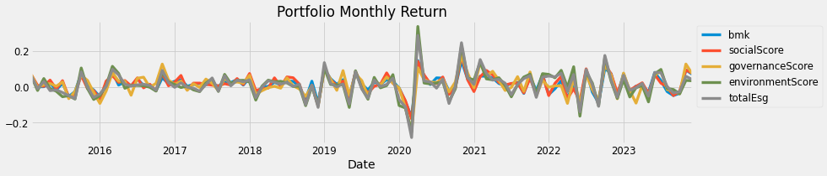

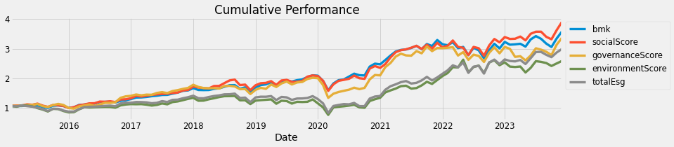

Annualized Return Annualized Volatility Sharpe Ratio

socialScore 0.170508 0.184886 0.851919

bmk 0.158190 0.170435 0.851878

governanceScore 0.158647 0.208054 0.700046

totalEsg 0.153360 0.246023 0.570515

environmentScore 0.138832 0.255769 0.491974

1. **Outperforming Sectors**: The governanceScore portfolio led in annualized return (21.41%) and Sharpe ratio (0.902), driven by strong performance in high-growth sectors like Information Technology.

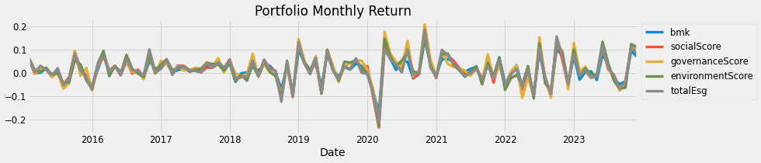

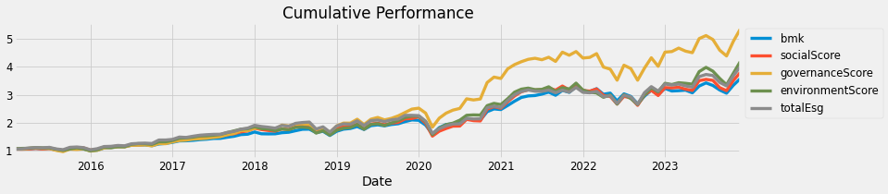

Annualized Return Annualized Volatility Sharpe Ratio

governanceScore 0.214058 0.222901 0.902009

bmk 0.158190 0.170435 0.851878

environmentScore 0.183549 0.209018 0.815956

totalEsg 0.176905 0.202135 0.810870

socialScore 0.172150 0.207947 0.765339

1. **Excluding Underperforming Sectors**: By removing Utilities, Real Estate, and Consumer Staples, the socialScore portfolio achieved superior returns (17.50%) while maintaining a competitive Sharpe ratio. Exclusion also reduced portfolio volatility.

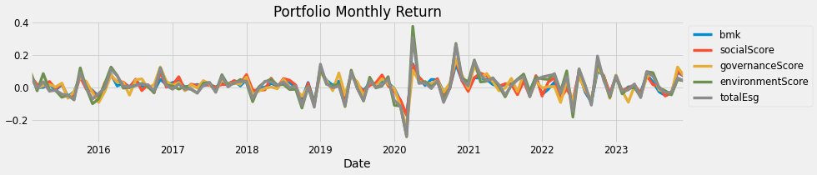

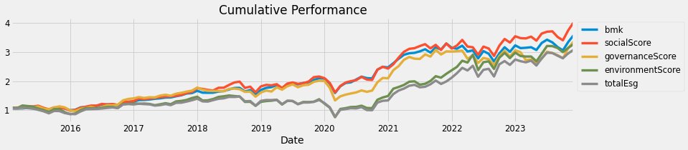

Annualized Return Annualized Volatility Sharpe Ratio

bmk 0.158190 0.170435 0.851878

socialScore 0.175030 0.191503 0.846098

governanceScore 0.158647 0.208054 0.700046

environmentScore 0.173949 0.286857 0.561077

totalEsg 0.161746 0.266462 0.558224

1. **Sector-Focused Selection**: The environmentScore portfolio excelled with a Sharpe ratio of 0.827, driven by strong performance in Financials and Health Care. These sectors provided a stable foundation for ESG-led investments.

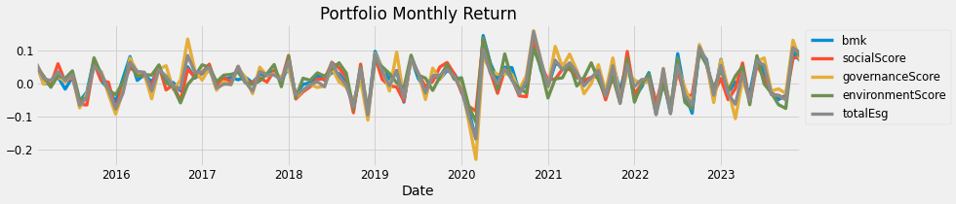

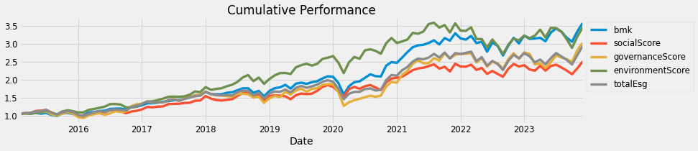

Annualized Return Annualized Volatility Sharpe Ratio

bmk 0.158190 0.170435 0.851878

environmentScore 0.154525 0.171124 0.827033

totalEsg 0.137733 0.180427 0.691320

governanceScore 0.145648 0.202793 0.654107

socialScore 0.117016 0.164495 0.632336

***Conclusion***

This analysis highlights the interplay between sustainability and profitability, offering practical insights for ESG-focused investors. Key findings include:

* Broad market performance reveals that portfolios incorporating ESG scores outperform benchmarks in risk-adjusted returns, particularly when prioritizing social or governance factors. Sectoral strategies further emphasize the importance of selecting high-performing industries such as Information Technology to enhance returns while avoiding underperforming sectors like Utilities to reduce volatility.
* Governance emerged as a key driver of portfolio success, with the governanceScore portfolio consistently delivering the highest returns and Sharpe ratio. Sector-specific strengths in Financials and Health Care underscore the value of focusing on ESG leaders within traditionally stable industries.
* By aligning investment strategies with ESG principles, investors can achieve a balance between ethical practices and financial performance. This study underscores the potential of ESG-driven approaches in modern portfolio optimization, demonstrating that sustainability and profitability can coexist in harmony.